Republic of the Philippines

**BOHOL ISLAND STATE UNIVERSITY**

**MAIN CAMPUS**

Tel: 038-4113289 Telfax: 038-5017516 

6300 Tagbilaran City

Vision: A premier S&T university for the formation of world class and virtuous human resource for sustainable development in Bohol and the Country.

Mission: BISU is committed to provide quality higher education in the arts and sciences, as well as in the professional and technological fields;

undertake research and development, and extension services for the sustainable development of Bohol and the country.

**Project #1**

**CpE 413 –** Operating System

**CPU Scheduling Algorithms**

Submitted by:

Perin, Max Angelo D.

Submitted to:

Engr. Edgar Uy II

1. **Project Description**

This project simulates process of various CPU scheduling algorithms; FCFS (First Come, First Served), SJF (Shortest Job First), Priority and Round-Robin Scheduling.

1. **Objectives and Goals**

Objective of this project is to develop an efficient algorithm that generalize the method of CPU scheduling decision take place when switches from running to waiting state, switches from running to reading state, switches from waiting to ready state.

1. **Problem**

The problem of this project is how we can solve if the desired number of processes is correct that can complete their execution per time unit.

1. **Flow Chart**

Start

char access

cin>>access

FCFS

Switch(access)

gets(access)

If(srcmp(“B1”,access2)==0)

SJF(NP)

If (strcmp(“B2”,access2)==0)

SJF(P)

PRIORITY

ROUND ROBIN

1. **Algorithm Analysis**

In CPU scheduling or CPU utilization, analyzation of algorithms is easy if you know the criteria. You must know the number of process that complete their execution per time unit, you must know the amount of the time to execute a particular process, you must know the sum of the periods spent waiting in the ready queue and you must know the time from the submission of request until the first response is produced.

1. **Snap Shot of the Functionalities**



**CPU Scheduling Algorithms**

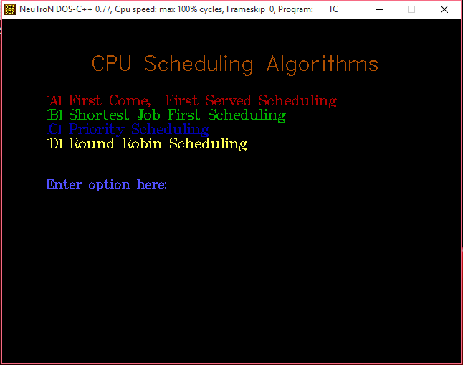

**CPU Scheduling Algorithms Menu**

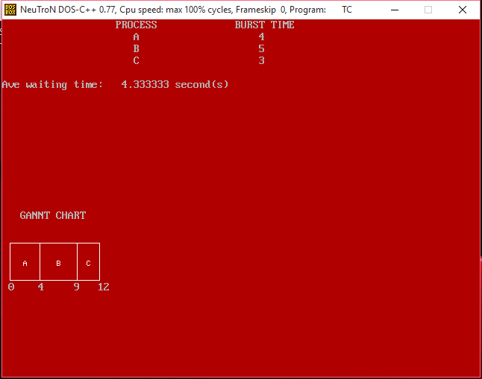

**Example process for First Come, First Served**

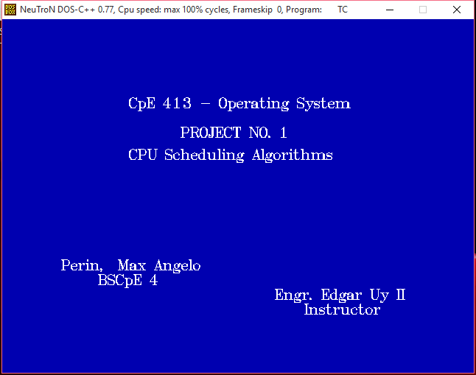

**CpE 413 – Operating System, Project No. 1**

1. **Code Snippets**

Using MDOS Turbo C++:

(The Main Program)

#include<iostream.h>

#include<graphics.h>

#include<dos.h>

#include<string.h>

#include<process.h>

#include<conio.h>

#include"fcfs.h"

#include"npreemp.h"

#include"preemp.h"

#include"prior.h"

#include"roundr.h"

char access,access2[20];

int gd=DETECT, gm;

main()

{

clrscr();

initgraph(&gd,&gm,"C:\\turboc3\\bgi");

setbkcolor(WHITE);

setcolor(RED);

settextstyle(TRIPLEX_FONT, HORIZ_DIR,9);

outtextxy(50,75,"CPU");

setcolor(GREEN);

settextstyle(TRIPLEX_FONT, HORIZ_DIR,9);

outtextxy(50,175,"Scheduling");

setcolor(BLUE);

settextstyle(TRIPLEX_FONT, HORIZ_DIR,9);

outtextxy(50,275,"Algorithms");

getch();

initgraph(&gd,&gm,"C:\\turboc3\\bgi");

setbkcolor(BLACK);

setcolor(6);

settextstyle(SANS_SERIF_FONT, HORIZ_DIR,4);

outtextxy(62,40," CPU Scheduling Algorithms ");

settextstyle(TRIPLEX_FONT, HORIZ_DIR,2);

setcolor(RED);

outtextxy(62,100,"[A] First Come, First Served Scheduling");

setcolor(GREEN);

outtextxy(62,120,"[B] Shortest Job First Scheduling");

setcolor(BLUE);

outtextxy(62,140,"[C] Priority Scheduling");

setcolor(YELLOW);

outtextxy(62,160,"[D] Round Robin Scheduling");

setcolor(9);

settextstyle(TRIPLEX_FONT, HORIZ_DIR,1);

outtextxy(62,218,"\t\tEnter option here: ");

gotoxy(32,15);

cin>>access;

switch(access)

{

case 'A': clrscr();

first_come_first_serve ffff;

ffff.create_sched_fcfs();

closegraph();

break;

case 'B': clrscr();

init_graphics();

init_graphics();

setbkcolor(BLACK);

setcolor(6);

settextstyle(SANS_SERIF_FONT, HORIZ_DIR,4);

outtextxy(62,40," CPU Scheduling Algorithms ");

settextstyle(TRIPLEX_FONT, HORIZ_DIR,2);

setcolor(GREEN);

outtextxy(62,120,"[B1] Shortest Job First (wNon-preemtive)");

outtextxy(62,140,"[B2] Shortest Job First (Preemptive)");

setcolor(9);

settextstyle(TRIPLEX_FONT, HORIZ_DIR,1);

outtextxy(62,218,"\t\tEnter option here: ");

gotoxy(32,15);

gets(access2);

closegraph();

if(strcmp("B1",access2)==0)

{

non_preemptive np;

np.create_sched_nonpreemp();

closegraph();

break;

}

else if(strcmp("B2",access2)==0)

{

preemptive pp;

pp.create_sched_preemp();

closegraph();

break;

}

else

{

return 1;

}

case 'C': clrscr();

priority pr;

pr.create_sched_priority();

closegraph();

break;

case 'D': clrscr();

roundrobin rr;

rr.create_sched_roundrobin();

break;

default: return 1;

}

clrscr();

initgraph(&gd,&gm,"C:\\turboc3\\bgi");

setbkcolor(BLUE);

settextstyle(TRIPLEX_FONT, HORIZ_DIR,2);

setcolor(WHITE);

outtextxy(62,100," CpE 413 - Operating System ");

outtextxy(62,140," PROJECT NO. 1 ");

outtextxy(62,170," CPU Scheduling Algorithms ");

outtextxy(70,320," Perin, Max Angelo ");

outtextxy(70,340," BSCpE 4 ");

outtextxy(70,360," Engr. Edgar Uy II ");

outtextxy(70,380," Instructor ");

getch();

return 0;

}